Scenario (CCI peaks)
CCI peaks at the peak of price, but then it does not peak at the next peak of the price -> the price will go down.
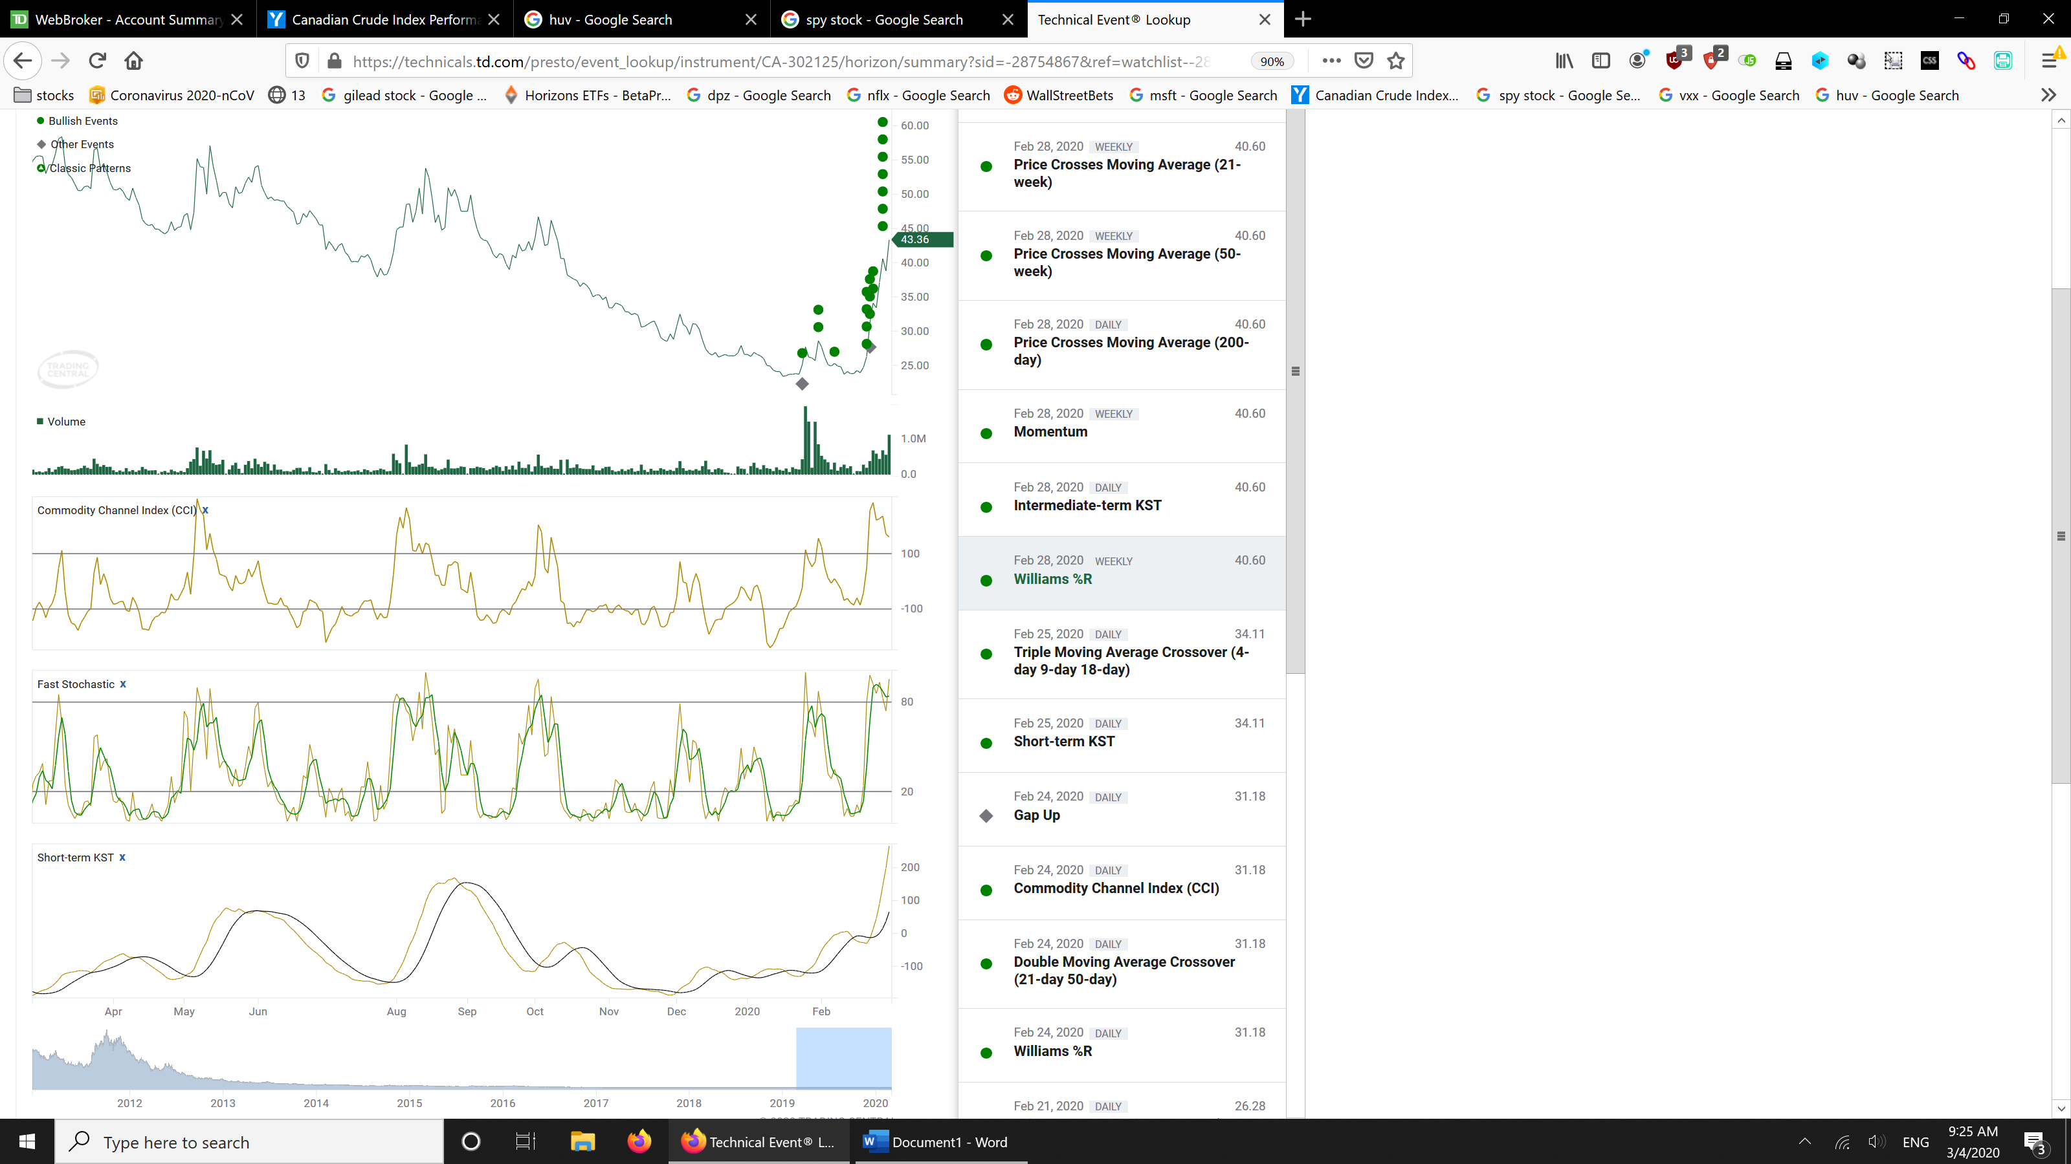

CCI high
When CCI is too high (say above 200, may depend on stocks), the stock will go down.

Historical market cap
If market cap in average is below price and then gradually goes up it means that people are buying that stock right now (And so, they are waiting to sell in the future). It also means people are encouraged to buy, and price would go up?
If market cap in average gradually goes down compared to the price it means that people have been selling the stock in the past (And, so they aree willing to buy more in the future)
